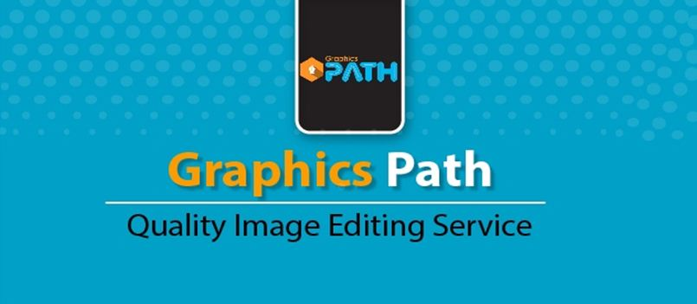

About Us
We are Graphics Path team, providing Image editing & graphic design services and we have more than 8 years’ experience in this field. As a result, Graphics Path has become an incomparable organization and first choice for the client.
Company Profile:
Graphics path is an online service portal that specializes in Photo Editing services for Products, Wedding, Studio, Jewelry photo and Event Photographers. We offer our services and customer support in all demographic languages around the world. Graphics path Photo Editing Company is the fastest growing Photo Retouching and Clipping Path Company that serves with dedication and shows quality results on time. We specialize in making our clients happy from our friendly and quality services, especially in photo industry; we offer the best and advance photo editing services. If you are looking for the best and professional photo editing services then contact us and avail great discounts for bulk orders and regular customers. Here is my previous sample work- https://goo.gl/7BKtUv
Our Goal:
Our aim is to co-operate photographers to make the best output for their clients and shoot great pictures. We work until client satisfaction is assured.
How does it help you?
Everything we do is based on two fundamental objectives:
• Making your life easier.
• Helping your business grow.

We achieve these goals by focusing on Quality, Turnaround Times and affordable Pricing. Once you've started working with us, you will see that we are truly committed to delivering a quality product so that you can focus on the other aspects of your life or business.
Why work with Graphics Path?

• 40+ Highly Skilled Production Staff
• PC & Mac Production systems
• 150 MBPS Internet lines
• Scalable Operations
• Simplified Workflows
• Fast Deliveries
• 24 Hours online support
• Lowest Cost
• Highest Quality
• Change to do correction again and again if client is not satisfied

Our Services:

➢ Clipping Path (Simple/Multiple/Complex Clipping)
➢ Background Removal & Re-sizing / Cropping
➢ Jewelry photo editing service
➢ Shadow making (Drop/Reflection / Natural Shadow)
➢ Image Masking (Alpha channel/ Layer/ Hair Masking)
➢ Photo Retouching (Headshots / Jewelry and Products Photo)
➢ Neck Joint / Ghost Mannequin Services
➢ Photo Manipulation Services
➢ Color Correction Services
➢ Corporate creative design service
➢ Logo Design Services
➢ Raster to Vector Conversion
Hello Sir,
Graphics Path is the Sister Concern of Present IT Solution. After launching this branch, we are working with a lot of shop owners, Photographers, Event Planners, Real Estate companies around the world. We would be pleased to work with you also for a long term opportunity with our best effort. Including the above services, we offer all other graphic design services that you may need. Just Ping us with your requirement to get best quotes.
We Accept: All Payment Methods that suits you.
Affordable Cost: As our production team is located in low labor cost region, we are able to work in very
Low price. Another important thing is we are 24 hours on!
Free Trial: We are warmly inviting you use our free trial, Try us right Now!! Or contact Email: info@graphicspath.com
*** We do image editing at very low cost for Bulk Orders (Bulk Order would be counted with 500+ Images)

With Best Regards,
James Rodriguez
Graphics Path
Skype: graphicspath
www.graphicspath.com
www.neckjoint.com

